Administration: Changing Serial Number
TITLE: | How to Change Your Serial Number
DATE: | May 2013
SUBJECT: | Changing Serial Numbers
ABSTRACT: | This document describes the process by which you can change the serial number of an existing Solidworks installation.

The Solidworks serial number cannot be changed from inside of the Solidworks program. It can only be viewed. To change the serial number, you have to modify the installation using the Windows Programs and Features. Please note that modifying an installation will not result in uninstalling the program; rather it will modify the installation to reflect the changed serial number. Modifying an installation is the recommended way to change your serial number.
Checking Your Serial Number
- Open Solidworks.
- Click on Help > About Solidworks.
Note: If Help is not visible in the upper left corner, then hover the cursor over the right hand side of the Solidworks logo and the help menu will appear.
Changing Your Serial Number
To change your serial number, you will have to modify the program using the Windows Programs and Features; the process is described below.
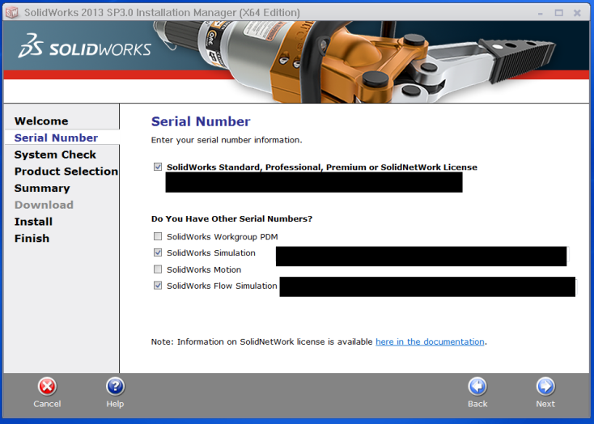
- Click on the Windows Start button (if you have Windows 8, press Windows key + i).
- Select Control Panel.
- Select Programs and Features (if you have Windows XP, open Add/ Remove a Program).
- Right-click on Solidworks 20xx Sp x.x.
- Select Change.
- Choose Modify the individual installation.
- Change the serial number in the Serial Number step.
- Continue through the installation until completed.
Note: If an activation error occurs, it may be that the license is currently being used by another machine. If you are unable to activate, please contact technical support.

